Amazon Rekognition
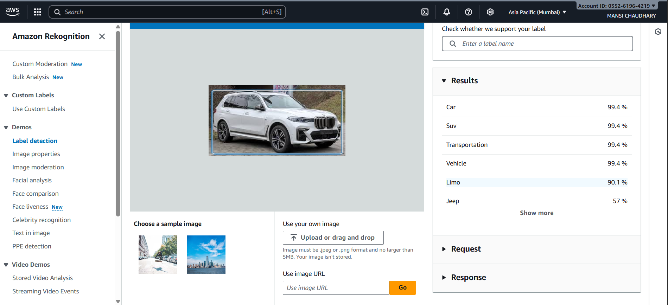
The screenshot shows the Amazon Rekognition Console under the Label Detection demo.
An image of a white SUV has been uploaded for analysis.
What Rekognition Detected
Amazon Rekognition analyzed the image and returned several labels with high confidence scores:
- Car – 99.4%
- SUV – 99.4%
- Transportation – 99.4%
- Vehicle – 99.4%
- Limo – 90.1%
- Jeep – 57%
These labels indicate that Rekognition is confident the image contains a car/SUV and is part of the transportation category.
Interface Elements Visible
- On the left side: Rekognition menu options
  - Label detection
  - Image properties
  - Image moderation
  - Facial analysis
  - Face comparison
  - Celebrity recognition
  - Text in image
  - PPE detection, etc.
- In the center: The uploaded image displayed with a detection box.
- On the right side:
  - A Results panel showing the detected labels and confidence percentages.
  - Expandable sections for Request and Response (API details).

